Department of Computer Science

Gujarat University

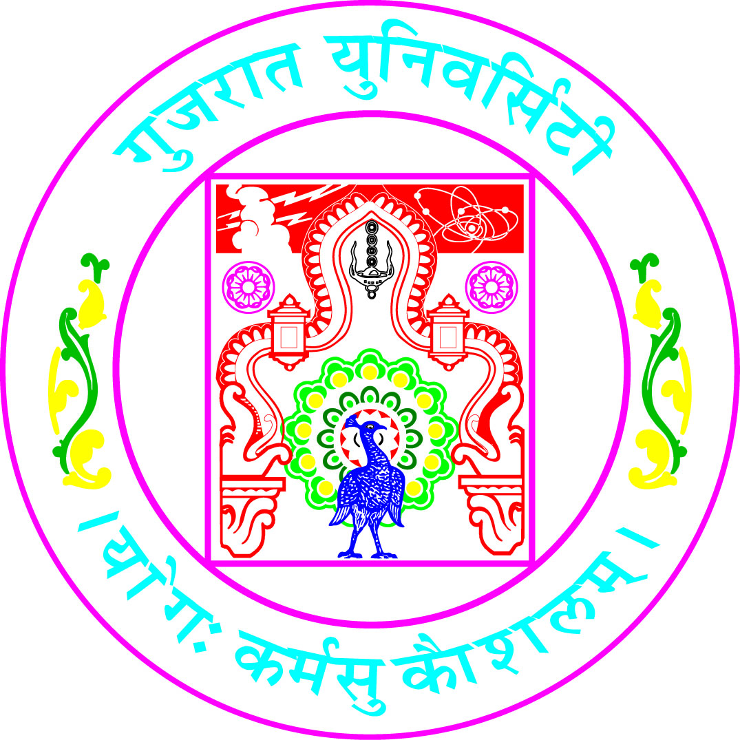

Certificate

Roll No: 36 Seat No: ______

This is to certify that Mr./Ms. ___Preksha Sheth_________________ student of MCA Semester – III has duly completed his/her term work for the semester ending in December 2020, in the subject of ______________Java Programming_____________ towards partial fulfillment of his/her Degree of Masters in Computer Applications.

Date of Submission Internal Faculty
12-12-2020

Head of Department

